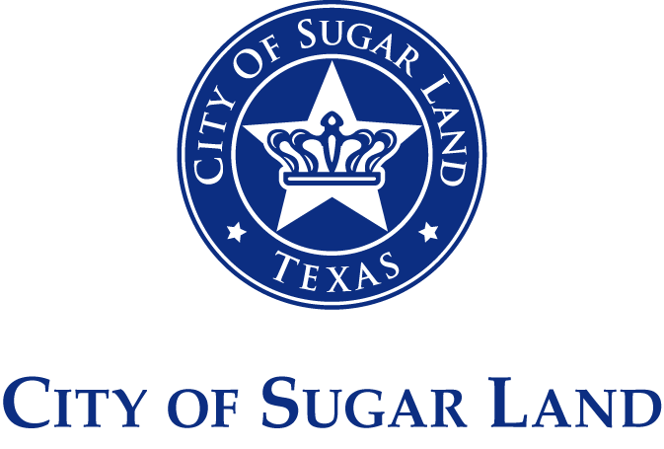

PARENTAL CONSENT, RELEASE AND WAIVER OF LIABILITY, ASSUMPTION OF RISK AND INDEMNITY AGREEMENT (“AGREEMENT”)
(FOR MINOR – UNDER THE AGE OF 18)

Name of Child (“Participant”): _______________________________ Date of Birth: ________________
Project or Activity (“Activity”): Civic Arts Anime Fest at Kempner High School
In consideration of the City of Sugar Land (“City”) allowing the Participant to participate in the Activity, I/we, as parents/guardians of the Participant, agree and affirm that: (1) I/we authorize the Participant to participate in the above Activity; (2) the Participant is physically and mentally fit to participate in the Activity; (3) I/we will ensure that the Participant complies with all procedures, instructions, and requirements in this Agreement; (4) I/we understand that neither I/we nor the Participant will receive any compensation for the Participant’s participation in the Activity; (5) I/we understand that the City may, at any time in its sole discretion, for whatever reason, cancel the Activity; (6) I/we understand that the Activity is conducted in coordination with the school and that school personnel remain responsible for general student supervision and discipline; (7) I/we grant the City, its event organizers and affiliates, all ownerships, rights, title, and interest, without compensation or payment to me/us or the Participant, to any and all photographs and video recordings, including the portions that contain the images and voices of me/us and/or the Participant, and the perpetual right to use, edit, alter, copy, publish, and release my/our and the Participant’s name, likeness, words, voice, photographs, and video recordings taken of us in any form and media, including websites, promotional materials, and to the media without requiring further consent; and (8) I/we acknowledge and agree that photographs or video recordings of the Activity may include artwork or materials created by the Participant, and I/we authorize the City to use such images and recordings, including the incidental display of such artwork or materials, for governmental, educational, or promotional purposes.
I/we voluntarily allow Participant to participate in the Activity and (1) I/we hereby expressly and specifically ASSUME ALL RISKS AND FULL RESPONSIBILITY OF ANY AND ALL LOSS, DAMAGES, INJURY OR HARM TO THE PARTICIPANT AND/OR THEIR PROPERTY while participating in the Activity; (2) I/we understand that the CITY WILL NOT INCUR ANY LIABILITY OF ANY NATURE as a result of the Participant participating in the Activity; (3) I/we understand that the CITY DOES NOT ASSUME ANY RESPONSIBILITY FOR AND HAS NO OBLIGATION TO PROVIDE FINANCIAL OR OTHER ASSISTANCE, including, but not limited to, medical, health or disability insurance, IN THE EVENT OF THE PARTICIPANT’S INJURY OR ILLNESS; and (4) in the event of an emergency, I/we consent for the City to seek reasonable and necessary treatment for the Participant including transporting the Participant to a hospital for emergency medical treatment, and I/we agree to ASSUME ALL EXPENSES AND COSTS ASSOCIATED WITH SUCH MEDICAL TREATMENT.
To the fullest extent allowed by law, on behalf of myself/ourselves, my/our heirs, executors, administrators, personal representatives, next of kin, spouse, guardians, and assigns (collectively “RELEASORS”), I/we hereby RELEASE, WAIVE, DISCHARGE AND COVENANT NOT TO SUE the City of Sugar Land, its City Council, officers, directors, agents, employees, contractors, Participants, event partners and affiliated organizations (collectively “RELEASEES”) from any and all claims, liability and causes of action or demands of any nature whatsoever, either in law or in equity, known and unknown, arising out of, relating to, or resulting from the Participant services or participating in the Activity, including, but not limited to, while traveling to or from, in/on, or upon the premises where the Activity is being conducted, including, but not limited to, any loss, damage or injury, including death, to the Participant and/or his/her property, REGARDLESS OF THE SOLE, JOINT, OR CONCURRENT NEGLIGENCE, NEGLIGENCE PER SE, GROSS NEGLIGENCE, STRICT LIABILITY, REGULATORY OR STATUTORY LIABILITY, TORT THEORY, ACT, OMISSION, FAULT, FAILURE TO ACT OR CAUSED BY THE PARTICIPANT, THE RELEASEES, OR OTHERWISE.
To the fullest extent allowed by law, RELEASORS further AGREE TO INDEMNIFY, HOLD HARMLESS AND DEFEND THE RELEASEES FROM AND AGAINST ANY AND ALL CLAIMS, INCLUDING THOSE BROUGHT BY OR ON BEHALF OF THE PARTICIPANT, causes of action, losses, liability, damages, costs, including court costs and attorney fees, that may incur due to the Participant services or participation in said Activity, REGARDLESS OF THE SOLE, JOINT, OR CONCURRENT NEGLIGENCE, NEGLIGENCE PER SE, GROSS NEGLIGENCE, STRICT LIABILITY, REGULATORY OR STATUTORY LIABILITY, TORT THEORY, ACTS, OMISSIONS, FAULT, OR FAILURE TO ACT CAUSED BY THE PARTICIPANT, THE RELEASEES, OR OTHERWISE.
It is my/our express intent that this Agreement binds the members of my/our family and spouse, if I/we are alive, and my/our heirs, assigns, and personal representative, if I/we are deceased, and deems as a RELEASE, WAIVER, DISCHARGE, COVENANT NOT TO SUE, INDEMNIFY AND HOLD HARMLESS the above-named RELEASEES. I/we agree that this Agreement is intended to be as broad and inclusive as permitted by state law. In the event any clause or provision of this Agreement is held invalid by any court of competent jurisdiction, the remainder of the Agreement continues to be binding on the parties. This Agreement is governed by the law of the State of Texas and a lawsuit may only be prosecuted in a court of competent jurisdiction located in or having jurisdiction in Fort Bend County, Texas.
If the Participant is less than 18 years of age, all parents/guardians must sign below. If only one parent or guardian sign this Agreement on behalf of the Participant, then the undersigned parent or guardian hereby covenants, warrants, represents and agrees that s/he is executing the Agreement on behalf of, and as an agent for, any other individual who may be a parent or guardian of the Participant, that s/he is fully authorized to do so, and that by executing this Agreement the undersigned is binding himself/herself, the Participant, and any other parent/guardian of the Participant, and all of their heirs, next of kin, assigns, and legal representatives.
I/WE AND MY/OUR CHILD, HAVE READ AND FULLY UNDERSTAND THE TERMS OF THIS PARENTAL CONSENT, RELEASE AND WAIVER OF LIABILITY, ASSUMPTION OF RISK, AND INDEMNITY AGREEMENT, AND UNDERSTAND THAT BY SIGNING THIS AGREEMENT WE HAVE GIVEN UP SUBSTANTIAL RIGHTS, AND I/WE ARE SIGNING THIS AGREEMENT VOLUNTARILY AND WITHOUT INDUCEMENT.

_______________________________________ _______________________________________
Name of Parent/Guardian 1 Signature
_______________________________________ _______________________________________
Date Contact Information

______________________________________ _______________________________________
Name of Parent/Guardian 2 Signature
_______________________________________ _______________________________________
Date Contact Information

ACKNOWLEDGEMENT
I understand that I am participating in the Activity voluntarily. I agree to follow all instructions provided by City staff and school personnel. I understand that I am expected to behave in a safe and responsible manner at all times.

Printed Name of Child/Participant: _____________________________________ Date: ______________
Signature of Child/Participant: ____________________________________________________________

EMERGENCY CONTACT INFORMATION
Name: ________________________________________ Relationship: _____________________
Address: ______________________________________ Telephone No.: ____________________

Name: ________________________________________ Relationship: _____________________
Address: ______________________________________ Telephone No.: ____________________

